Head Teacher: Mrs Carmel Dodds

Deputy Head Teacher: Mrs Jackie Robinson
Kingsland Gardens
Kingsthorpe
Northampton
NN2 7BH

Telephone: (01604) 714399
Fax: (01604) 714672
E-mail:
head@thegoodshepherd.northants-ecl.gov.uk

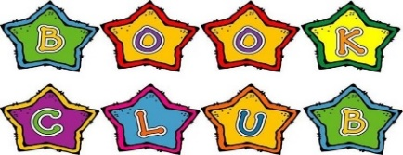
THE GOOD SHEPHERD CATHOLIC PRIMARY SCHOOL
The Catholic Diocese of Northampton
“Following Jesus, The Good Shepherd, in all we say and do”
Catholic Diocese of Northampton

Wednesday, 12 February 2020

Dear Parents/Carers,

We are delighted to let you know that after the half term holiday, we will be introducing an After School Book Club for Years 5 and 6 on Wednesdays from 3.15-4.15. It will be run by our school Librarian, Mrs McDonald, who has very kindly volunteered her time.

The club will run for six weeks initially, until the Easter holidays, and will be located in our school Library. Children will have the opportunity to share their favourite books and authors with each other, as well as having the opportunity to explore and review new authors and discuss their preferences.

It will be open to a maximum of 20 children and places will be allocated on a first come first served basis. There will not be any costs involved.

We are very excited about this new club. We hope it will inspire the children to develop a love of books and reading, which will stay with them for the rest of their lives! We look forward to seeing you there!

Yours sincerely,

Mrs Kelly (KS2 Reading Lead) Mrs McDonald (Library Co-ordinator)

Book Club

I give permission for my child _______________________________________________ in class ________ to attend Book Club from 3.15-4.15, beginning Wednesday 26th February for six weeks. I will pick my child up at 4.15.
Signature_____________________________________________________ Date____________________

Lunchtime Library!
Come and join us for some quiet reading time in the library at lunchtimes!
When? | Who? | Time? | Teacher?
Mondays | Years 1 and 2 | 12.30- 1.00pm | Mrs Bowen
Wednesdays | Years 3 and 4 | 12.45-1.15pm | Mrs Kelly
Fridays | Years 5 and 6 | 12.45-1.15pm | Mrs McDonald

