

The Good Shepherd
Catholic Primary School

Following Jesus,
The Good Shepherd,
in all we say and do

Pre-School
Admission Pack

Pupil Data Collection Form
This form is used to collect essential information about your child. Please complete all sections clearly and accurately. If any information changes, notify the school as soon as possible.
The school and the Local Education Authority are required under Data Protection legislation to comply with essential good practice in respect of the information collected here and to manage it securely. The individuals who are the subject of the information or who have parental/guardian responsibility are generally entitled to see the information and are encouraged to help keep the information up to date. This information will be used for educational, welfare, planning or managerial purposes (Please see our Privacy Policy for more details.)

PLEASE USE BLOCK CAPITALS

1. Child’s Information
Legal Surname
Legal Forename
Middle Name(s)
Other Names Known By
Date of Birth
Gender
Date of Admission

2. Parent/Guardian Information
 | Parent/Guardian 1 | Parent/Guardian 2
Full Name
Parental Responsibility (Yes/No)
Court Order Issued (if applicable) (Yes/No)
National Insurance/Asylum Support No.
Date of Birth
Home Address
Postcode
Telephone Number(s)
Email Address
I am happy to receive e-mails from the school (Yes/No)
Child lives at address? (Yes/No)

3. Emergency Contact Information
Priority | Name | Relationship | Address | Phone Number(s)
1
2
3
4

4. Medical & Dietary Information
Doctor’s Name & Surgery
Child’s NHS Number
Dietary Requirements | ☐ Vegetarian ☐ No Pork ☐ Halal ☐ Kosher ☐ Gluten-Free ☐ Dairy-Free ☐ Nut Allergy ☐ Other:
Medical Conditions | ☐ Asthma ☐ Eczema ☐ Diabetes ☐ Epilepsy ☐ Other:
Medication Required? (Yes/No)
Details of Condition & Medication
Disability & information
Last Hearing Test (Date & Result)
Last Eye Test (Date & Result)
Any outside agency involvement? | (e.g., speech therapist, psychologist, etc.)

5. Additional Information
Child’s Position in Family (1st, 2nd, etc.)
Religion
Festivals Observed/Special Religious Requirements
Mode of Transport to School | ☐ Walk ☐ Car ☐ Bus ☐ Train ☐ Cycle ☐ Other:
First Language of Child
Home Language(s)
Ethnicity (please select all that apply) | ☐ White ☐ Mixed or Multiple Ethnic Groups  ☐ Asian or Asian British ☐ Black, African, Caribbean or Black British  ☐ Other Ethnic Group please state:
Country of Birth
Date of Arrival in UK (if applicable)
Asylum Seeker/Refugee (Yes/No)

6. Setting History
Previous setting(s) | Address | Dates Attended | Language(s) Taught In

7. Child’s Interests & Additional Notes
What does your child enjoy at school?
What does your child find challenging?
Achievements so far?
Aspirations?
Hobbies/Interests?
Any trauma or life events we should be aware of?
Anything else you'd like us to know?

8. Consent & Permissions
Parents must inform the Pre-School Staff in advance if a different person will be collecting their child. We operate a password system which the person collecting your child must know. Any unauthorized person trying to collect a child will not be allowed to leave with the child and the parent of the child will be contacted immediately and asked to make appropriate arrangements.

Password ……………………………………………………………………………………………………………
Activity | Yes | No
School Trips: I give permission for my child to participate in educational visits and trips organised by the school. | ☐ | ☐
Photographs & Videos: I give permission for my child’s photograph/video to be used around school, in school publications, website, and social media. | ☐ | ☐
Forest School: I give permission for my child to participate in Forest School on school site and use tools appropriate to their age group. | ☐ | ☐
Local Walks: I give permission for my child to take part in local off-site visits (e.g., trips to the library, park). | ☐ | ☐
Medical Treatment: In case of emergency, I authorise the school to seek medical treatment for my child. | ☐ | ☐
Plasters: I agree that the Nursery designated First Aider can apply plasters when deemed necessary. | ☐ | ☐
Toileting: I give permission for my child to be changed by the Nursery Staff. | ☐ | ☐
Sun cream: I agree that the staff can apply sun cream to my child. I also agree to supply sun cream for my child. | ☐ | ☐
Watching PG Films: I give permission for my child to watch PG-rated films for educational or entertainment purposes under school supervision. | ☐ | ☐
Further information will be sent out to parents/carers via MCAS prior to activities, events etc.
Permission can be withdrawn at any time by e-mailing the school office.

9. Funding
I can confirm that my child will attend The Good Shepherd Catholic Pre-School for the 30 funded hours and I have the following DERN Funding code: ___________________________________________

I do not have a DERN funding code and I can confirm I have discussed my 15 hour place with the EYFS team at The Good Shepherd Pre-School, my child will attend in AM / PM (please circle).

10. Declaration

I confirm that the above information is accurate and will notify the school of any changes.
Parent/Guardian Signature: ___________________________________________________________
Date: ________________________________________________________________________________
Thank you for completing this form. Please return it to the school office at your earliest convenience.

Supplementary Information Form for Children Seeking Admission to
The Good Shepherd Catholic School

This form is used to provide additional information to support an application if you are applying under criteria 10 or 11. You may wish to refer to the school’s admission criteria for fuller information.

This form on its own does not constitute an application. You must also apply via the West Northamptonshire Council website in accordance with Local Authority published deadlines.

Full Name of Child
Address
Postcode
Date of Birth
Contact Telephone Number
Contact email

Declaration by Priest, Minister or Faith Leader
I confirm that I support this application
Name and address of priest faith leader: Name of congregation/place of worship:

Christian denomination or religious faith: Signature of priest/minister/faith leader:

Seal/Stamp Date:

Please return your completed forms by the admission deadline to: The Good Shepherd Catholic Primary School, Kingsland Gardens, Northampton, NN2 7BH or office@tgs.nor.olicatschools.org

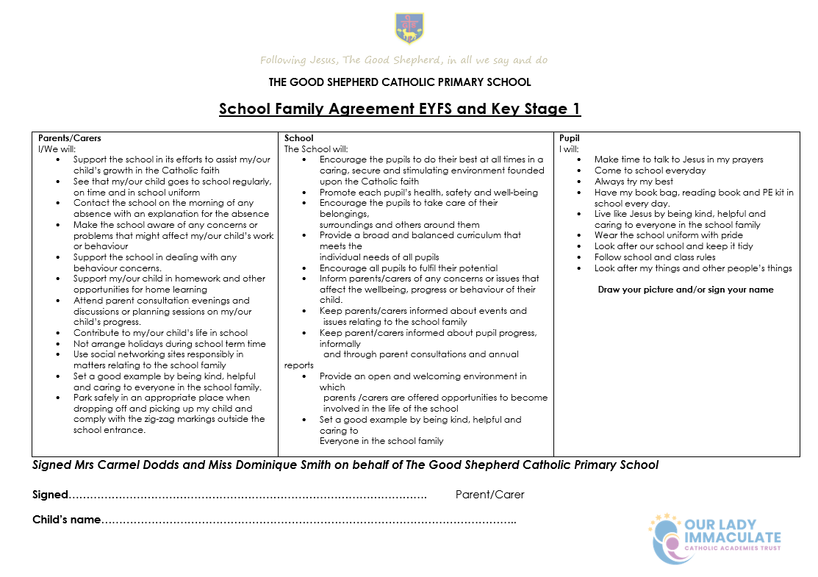

Parent/Carer Communication Protocol

Purpose:
To promote respectful, constructive, and collaborative communication between home and school in the best interests of all students and staff.

1. Our Commitment:
We are committed to:
• Responding to concerns in a timely, respectful, and professional manner.
• Working in partnership with parents/carers to support every child’s wellbeing and progress.
• Creating a safe working environment for our staff, free from abuse or intimidation.

2. Expectations for Communication:
We kindly ask that parents/carers:
• Use respectful language at all times in written and verbal communication.
• Avoid personal attacks, threats, or accusatory language.
• Allow staff reasonable time to respond to emails (e.g. within 2–3 working days).
• Understand that staff may not be able to respond outside school hours or during teaching time.
• Raise concerns through the appropriate channels (class teacher, then middle/senior leader, then headteacher, in that order).

3. Inappropriate Communication:
We consider the following to be unacceptable:
• Aggressive, rude, or threatening language (written or spoken).
• Excessive or repetitive emails/communications without allowing time for response.
• Publicly criticising staff on social media or in front of children.

4. Response to Breaches:
If a parent/carer behaves inappropriately, the school may:
• Issue a polite reminder of this policy.
• Request communication be made through a specific channel (e.g. in writing only).
• Set boundaries (e.g. meeting only in presence of a senior staff member).
• In serious cases, involve the local authority and/or ban the parent from the school site.

5. Escalating Concerns:
If a parent remains dissatisfied, they may follow the school’s complaints procedure, available on our website or by request.

Signed Mrs Carmel Dodds & Miss Dominique Smith on behalf of The Good Shepherd Catholic Primary School

Parent/Carer signature: _____________________________________________ date: __________________

