PE TOPICS:
To Access all activities Mr Pearce and Mr Flanagan is wanting you to try:
Click:https://www.thegoodshepherdcatholicprimaryschool.org.uk/page/?title=Stay+Active+with+Mr+Pearce&pid=71
or
- Go to: The Good Shepherd School website
- Click: MENU
- Click: Learning with us
- Scroll down to yellow bars and click: Home Learning- Covid-19
- Scroll right to bottom of page to Yellow Bars- Click: Stay Active with Mr Pearce
All material for lessons/activities below will be accessible here.

Outdoor Adventurous Activity and Multi Skill Development
School Games value focus: Teamwork Gospel value Focus: Forgiveness

Physical Activity Starter: Try a new Joe Wicks HIIT Workout!

Click here to access his YouTube channel:
https://www.youtube.com/channel/UCAxW1XT0iEJo0TYlRfn6rYQ
Have a go at one of his workouts!

How did you feel after the workout?
Which exercises did you find most challenging?

PE lesson Part 1: Outdoor Adventurous Activity:
Have a go at all the activities shown below:
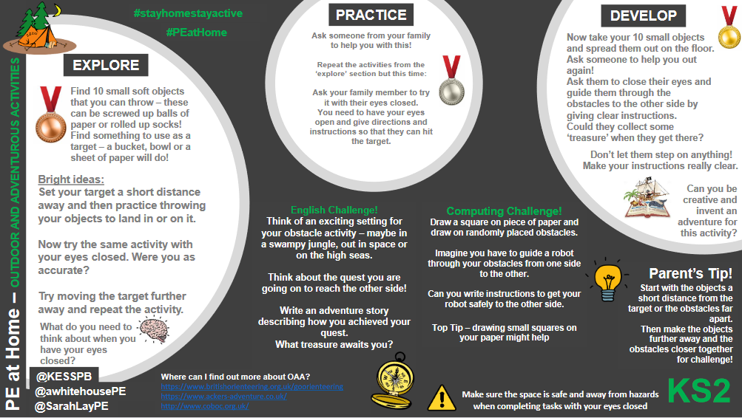

PE Lesson Part 2: Multi Skill Development: Personal Challenges
Speed Stacking!
Can you beat Mr Pearce’s Time?
Click here to see Mr Pearce’s video example: https://www.thegoodshepherdcatholicprimaryschool.org.uk/page/?title=Stay+Active+with++Mr+Pearce&pid=71
Video titled “Speed Stacking”

Northamptonshire Sport Challenge:
Every week Northamptonshire sport will be setting a challenge, if you complete make sure you let Mr Pearce know as you get participation points for the school!
ben@schoolsportspecialists.co.uk
Can you beat your personal best?
What could you do differently to improve?

Link to see the challenge is here: Northamptonshire Sport Twitter page: The new challenge will be updated at 10am every Monday:
https://twitter.com/Nsport?ref_src=twsrc%5Egoogle%7Ctwcamp%5Eserp%7Ctwgr%5Eauthor

Research/Written Task, Mindfulness:
Write down 5 things you are looking forward to doing this year?
e.g Learn to swim, Read 20 books, go on a walk every day

Can you set these as your yearly goals?

What do we mean when we set a goal?

Research task: What are SMART goals?

Cross Curricular Activities: MATHS ON THE MOVE!
Have a go at the challenges below
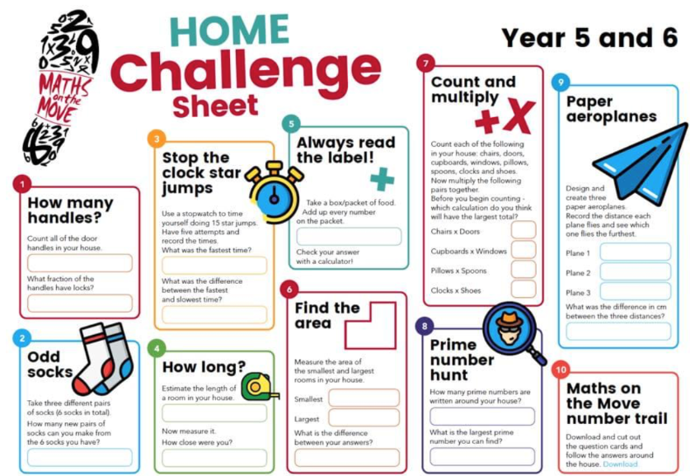
EXTRA TIME
For those keen for more!
Go to:
Mr Pearce’s Physical activity Weekly Timetable- This gives you tasks to try every day!
“Getting more active” Document. This has lots of links to access

For more PE lessons ideas:
- https://www.youtube.com/user/WestYorkshireSport

Afterschool Sports Club: Youth Sports Trust: Weekdays 5pm:
https://www.youtube.com/user/YouthSportTrust/videos

SEE YOU SOON!!
Mr Pearce

