PE TOPICS:
To Access all activities Mr Pearce and Mr Flanagan is wanting you to try:
Click:https://www.thegoodshepherdcatholicprimaryschool.org.uk/page/?title=Stay+Active+with+Mr+Pearce&pid=71
or
- Go to: The Good Shepherd School website
- Click: MENU
- Click: Learning with us
- Scroll down to yellow bars and click: Home Learning- Covid-19
- Scroll right to bottom of page to Yellow Bars- Click: Stay Active with Mr Pearce
All material for lessons/activities below will be accessible here.

Outdoor Adventurous Activity and Multi Skill Development
School Games value focus: Teamwork Gospel value Focus: Forgiveness

Physical Activity Starter: Superhero Workout!!
Be an Avenger, Spiderman or Black Panther as you get your heart racing
Click on NETFLEX (NOT NETFLIX!!)
NETFLEX .pptx - Google Drive
(This can also be found in get active files on the school website, under title PA & PE Home Learning)
How did you feel after the workout?
Which exercises did you find most challenging?

PE lesson Part 1: Outdoor Adventurous Activity:
Have a go at a scavenger hunt! Work in a team!

Create your own list!

PE Lesson Part 2: Multi Skill Development:
Have a go at Northamptonshire Sports Weekly Personal Challenge!

Every week Northamptonshire sport will be releasing a challenge for every school to have a go at. The challenge will be released at 10am on the link below:
If you have a go let Mr Pearce know and get a participation point for the school!
Mr Pearce email: ben@schoolsportspecialists.co.uk
Link to challenge videos:
https://twitter.com/Nsport?ref_src=twsrc%5Egoogle%7Ctwcamp%5Eserp%7Ctwgr%5Eauthor

Worksheet- Partner Support sheet- try some of these below with your family:
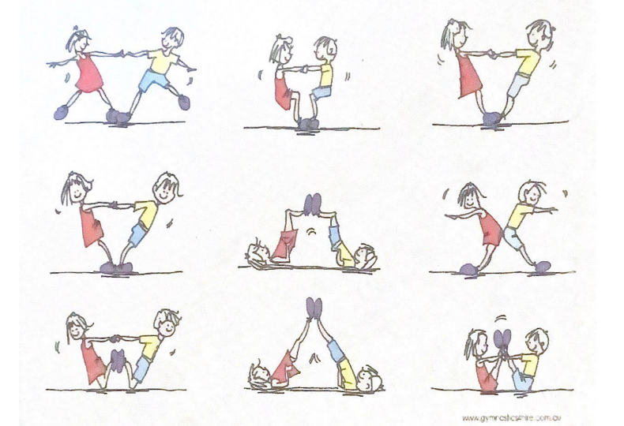
Send some picture in of you trying!!

Research/Written Task, Forgiveness :

What is Forgiveness?

When do you find it hard to forgive someone?

Cross Curricular Activities: Get creative!
Have a go at designing a new game. Some ideas below…..

What can you create?

EXTRA TIME
For those keen for more!
NORTHAMPTONSHIRE SPORT WEEKLY CHALLENGE: get points for your school!
Every week Northamptonshire sport will be releasing challenge for every school to have a go at. The challenge will be released at 10am on the link below:
If you have a go let Mr Pearce know and get a participation point for the school!
Mr Pearce email: ben@schoolsportspecialists.co.uk
Link to challenge:
https://twitter.com/Nsport?ref_src=twsrc%5Egoogle%7Ctwcamp%5Eserp%7Ctwgr%5Eauthor

Go to:
Mr Pearce’s Physical activity Weekly Timetable- This gives you tasks to try every day!
“Getting more active” Document. This has lots of links to access
PA and PE Home Learning- Document in Get active section
For more PE lessons ideas:
- https://www.youtube.com/user/WestYorkshireSport

Afterschool Sports Club: Youth Sports Trust: Weekdays 5pm:
https://www.youtube.com/user/YouthSportTrust/videos

SEE YOU SOON!! Mr Pearc

