PE TOPICS:
Outdoor Adventurous Activity and Multi Skill Development
School Games value focus: Teamwork Gospel value Focus: Forgiveness

Physical Activity Starter: Try the HOME COURT CHALLENGE!
See Mr Pearce’s attempt here, then have a go! https://www.youtube.com/watch?v=tt57TThev1c 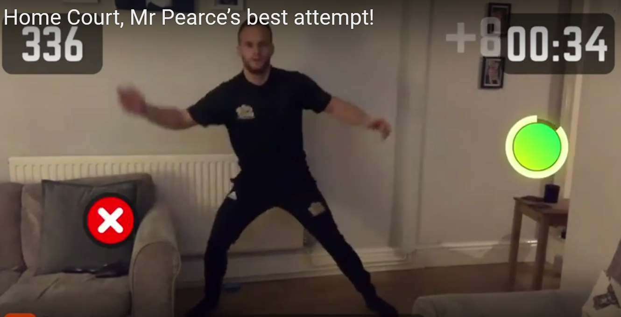
To have a go you need to download the app “HomeCourt”, click “Agility” and then Click “Reaction”
How did you feel after the workout?
What did you do to improve?

PE lesson Part 1: Outdoor Adventurous Activity:
Have a look at what you can complete from the National Trust Challenges below:
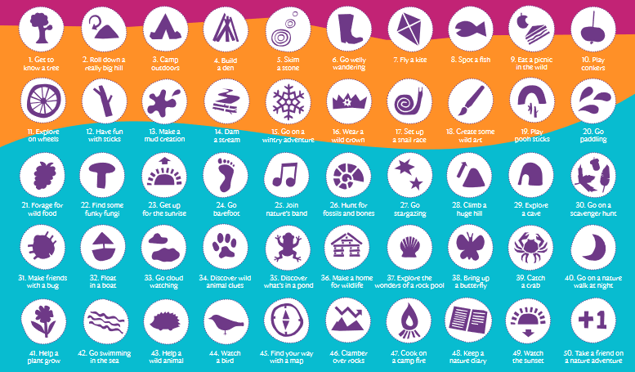

PE Lesson Part 2: Multi Skill Development: Clown and Acrobats!
Mr Pearce has done some videos, so you can see what to do, access here:
https://www.youtube.com/channel/UCqoFCJR6hInZrArFwgTFYuw

Video 1: Using Clown Catches as Acrobats:

Walking and catching
Balancing on pillow and catching
Walking along a tightrope and catching
Jumping from 1 foot to 1 foot, 2 feet to 1 foot, 1 to two feet (using tight rope)

Video 2: Acrobat Obstacle
Set up an obstacle course with all challenges above

Send some pictures in of you trying!!

Research/Written Task: Identify the flags!


Cross Curricular Activities: Paralympics worksheet
Have a go at designing a new game kit. Send to ben@schoolsportspecialists.co.uk
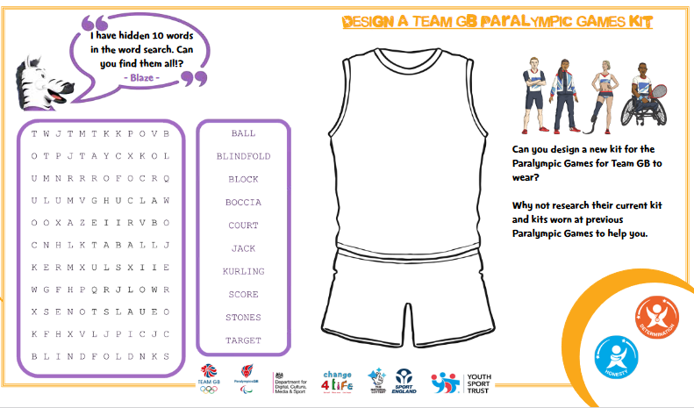
EXTRA TIME
To Access all activities Mr Pearce and Mr Flanagan is wanting you to try:
Click:https://www.thegoodshepherdcatholicprimaryschool.org.uk/page/?title=Stay+Active+with+Mr+Pearce&pid=71
or
- Go to: The Good Shepherd School website
- Click: MENU
- Click: Learning with us
- Scroll down to yellow bars and click: Home Learning- Covid-19
- Scroll right to bottom of page to Yellow Bars- Click: Stay Active with Mr Pearce
All material for lessons/activities below will be accessible here.

For those keen for more!
Have a go at Northamptonshire Sports Weekly Personal Challenge!
Every week Northamptonshire sport will be releasing a challenge for every school to have a go at. The challenge will be released at 10am on a Monday on the link below:
We are on Week 2- Sportshall Athletics
LOG YOUR SCORE HERE:
https://www.northamptonshiresport.org/virtual-school-games-challenges
Link to view challenge:
https://www.northamptonshiresport.org/virtual-school-games-challenges1
Go to:
Mr Pearce’s Physical activity Weekly Timetable- This gives you tasks to try every day!
“Getting more active” Document. This has lots of links to access
PA and PE Home Learning- Document in Get active section
For more PE lessons ideas:
- https://www.youtube.com/user/WestYorkshireSport
Afterschool Sports Club: Youth Sports Trust: Weekdays 5pm:
https://www.youtube.com/user/YouthSportTrust/videos
SEE YOU SOON!! Mr Pearce

