PE TOPICS:
Outdoor Adventurous Activity and Multi Skill Development
School Games value focus: Teamwork Gospel value Focus: Forgiveness

Physical Activity starter: Try the HOME COURT CHALLENGE!
See Mr Pearce’s attempt here, then have a go! https://www.youtube.com/watch?v=tt57TThev1c 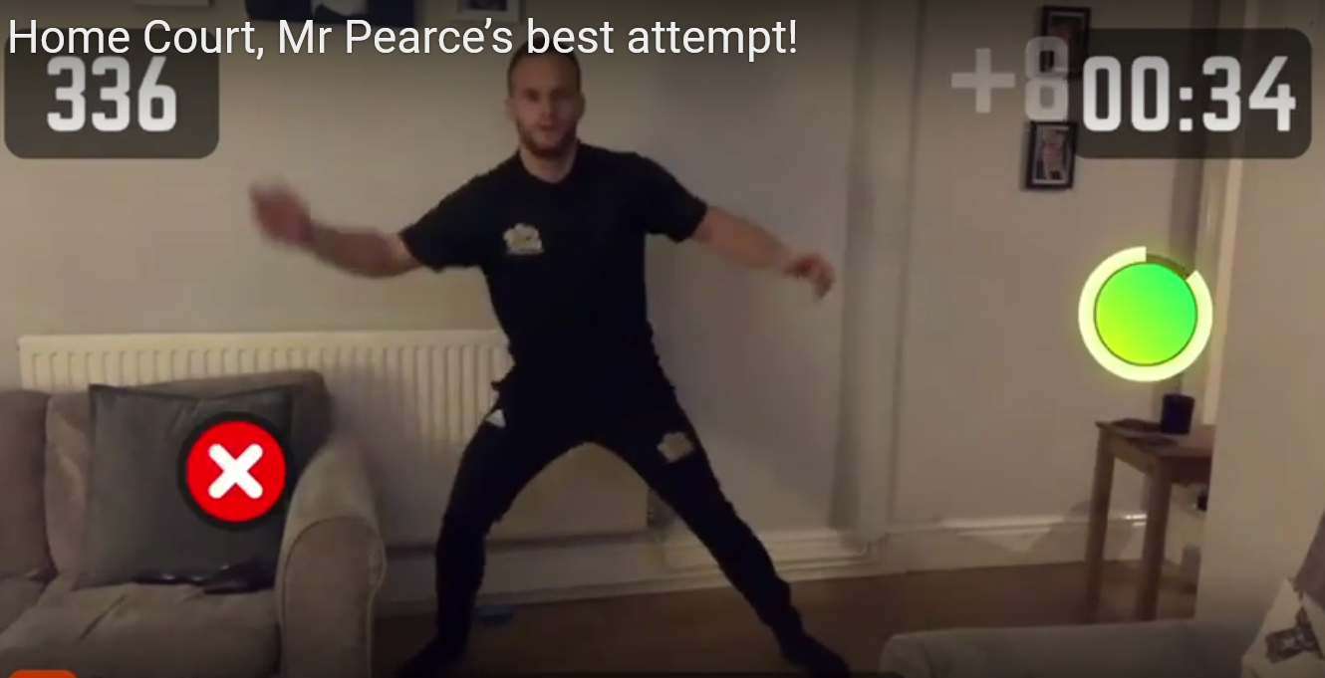
To have a go you need to download the app “HomeCourt”, click “Agility” and then Click “Reaction”
How did you feel after the workout?
What did you do to improve?
Can you try one of the other challenges?

PE lesson Part 1: Outdoor Adventurous Activity:
Have a look at what you can complete from the National Trust Challenges below:
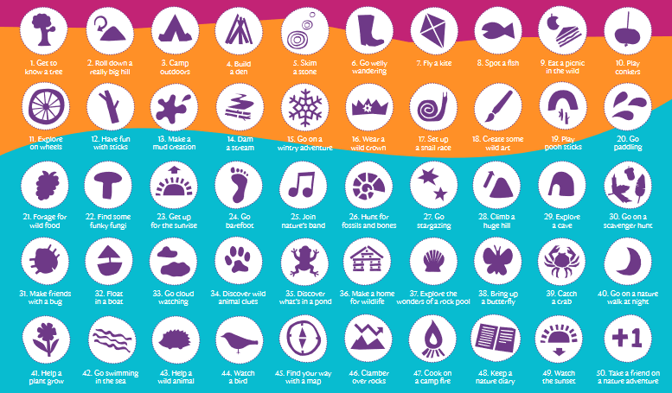
Which challenges can you do now?
Which challenges will you have to plan for?

PE Lesson Part 2: Multi Skill Development:
Warm up activity: Have a go at Mr Pearce’s Acrobat Challenges:
Rope Walk
Pillow Balance
Chair Hold
Then watch the Video 1: using Clown catches as Acrobats, Have a go at:
Walking and catching
Balancing on pillow and catching
Walking along a tightrope and catching
Jumping from 1 foot to 1 foot, 2 feet to 1 foot, 1 to two feet (using tight rope)
Video link here: https://www.youtube.com/channel/UCqoFCJR6hInZrArFwgTFYuw/videos
Or on the school website: Home learning, Stay Active with Mr Pearce

Have a go at Northamptonshire Sports Weekly Personal Challenge!

Every week Northamptonshire sport will be releasing a challenge for every school to have a go at. The challenge will be released at 10am on a Monday on the link below:
We are on Week 2- Sportshall Athletics
LOG YOUR SCORE HERE:
https://www.northamptonshiresport.org/virtual-school-games-challenges
Link to view challenge:
https://www.northamptonshiresport.org/virtual-school-games-challenges1

Research/Written Task: Identify the flags!

___________________________________________________________________________
MINDFULLNESS:
Do some COSMIC YOGA

LINK: https://www.youtube.com/user/CosmicKidsYoga

How did you feel after doing some Cosmic Yoga?
Is it something you would like to continue to do?
Cross Curricular Activities: Paralympics worksheet
Have a go at designing a new game kit. Send to ben@schoolsportspecialists.co.uk
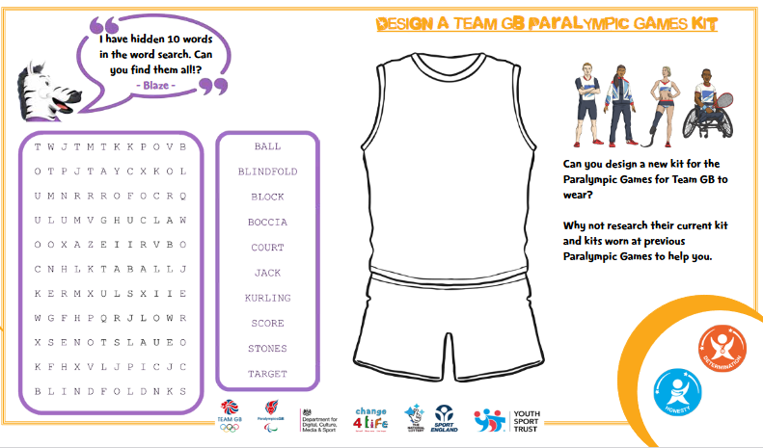
EXTRA TIME
For those keen for more!
Have a go at Northamptonshire Sports Weekly Personal Challenge!

Every week Northamptonshire sport will be releasing a challenge for every school to have a go at. The challenge will be released at 10am on a Monday on the link below:
We are on Week 2- Sportshall Athletics
LOG YOUR SCORE HERE:
https://www.northamptonshiresport.org/virtual-school-games-challenges
Link to view challenge:
https://www.northamptonshiresport.org/virtual-school-games-challenges1

Go to:
Mr Pearce’s Physical activity Weekly Timetable- This gives you tasks to try every day!
“Getting more active” Document. This has lots of links to access
PA and PE Home Learning- Document in Get active section
For more PE lessons ideas:
- https://www.youtube.com/user/WestYorkshireSport

Afterschool Sports Club: Youth Sports Trust: Weekdays 5pm:
https://www.youtube.com/user/YouthSportTrust/videos

SEE YOU SOON!! Mr Pearce

