PE TOPICS:
Net/Wall Development and Hand Invasion Development
School Games value focus: Self Belief Gospel value Focus: Courage
Health and Wellbeing Focus: Growth Mindset

So this half term we will be focusing on the following areas, listed above.
Net/Wall development that can link skills to sports such as Tennis, Badminton, Table Tennis and Volleyball.
Hand Invasion Development that can link skills to sports such as Handball, Dodgeball, Basketball, Netball, Ultimate Frisbee and Tchoukball.
Linking to our school games value focus of Self-belief, Gospel value of Courage and looking to have a growth mindset.
Please try and complete all tasks set below in this week’s PE plan.
Physical Activity starter:
JUST DANCE!
Click the link: https://www.youtube.com/watch?v=gVfgTw_W_JY
Type in your favourite song on JUST DANCE. Can you copy the dance moves!? My favourite is WAKA WAKA. What is yours?

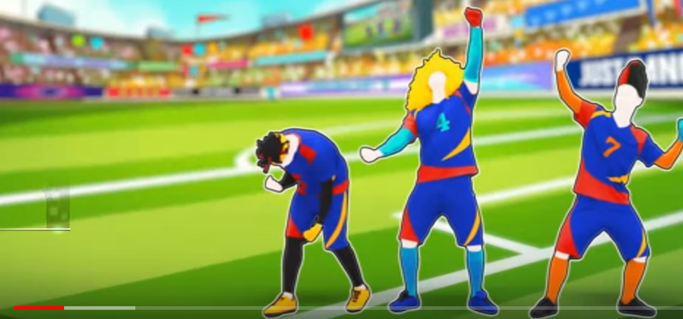
PE lesson Part 1: Hand Invasion Development: Explore, Practice and Develop in this PE at Home Lesson below:
BASKETBALL session 1
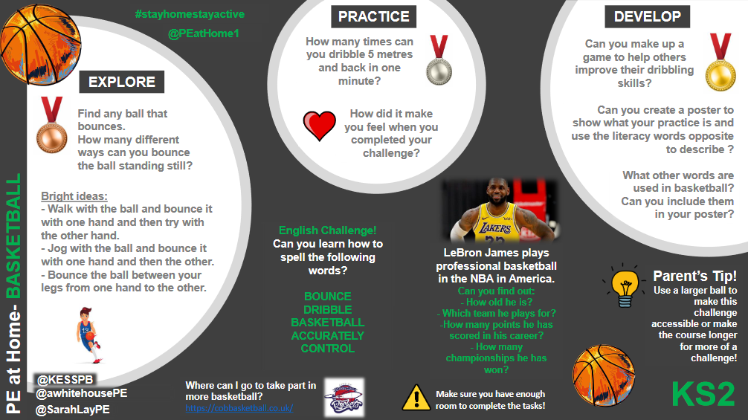
Cross Curricular: Basketball Worksheet
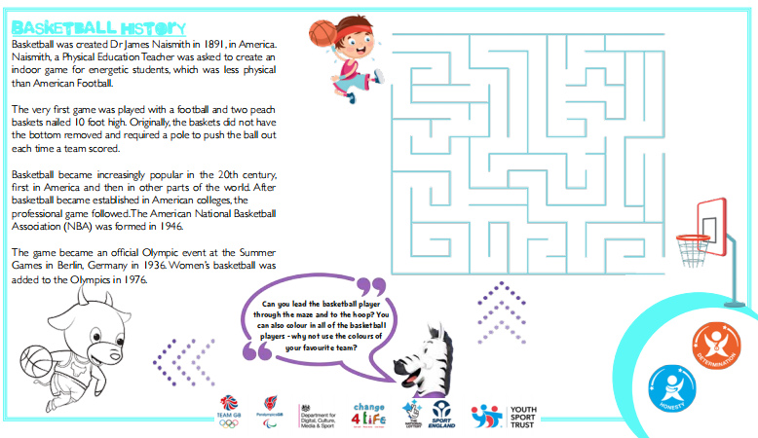

PE Lesson Part 2: Net/Wall Development:
Click the link, watch Mr Pearce’s Videos and have a go yourself!
Balloon Play!
Video 1: Body Tap up challenge
Link: https://www.youtube.com/channel/UCqoFCJR6hInZrArFwgTFYuw
Video 2: Using the Back and Forehand with Racquet hand
Link: https://www.youtube.com/channel/UCqoFCJR6hInZrArFwgTFYuw


Have a go at Northamptonshire Sports Weekly Personal Challenge!

Every week Northamptonshire sport release a challenge for every school to have a go at. The challenge will be released at 10am on a Monday on the link below:
We are on Week 5
LOG YOUR SCORE HERE:
https://www.northamptonshiresport.org/virtual-school-games-challenges
Link to view challenge:
https://www.northamptonshiresport.org/virtual-school-games-challenges1

Our school have been in the top 10 in county every week! Keep it up!

Research/Written Task:
A Growth Mindset
A growth mindset is believing in the power of yourself and your brain! We know our intellect and abilities develop when we try difficult things, use the right strategies, and don't give up. So a growth mindset is when we know, with practice, we will get better at something

Can you match the uncoloured statement with a coloured growth mindset statement?
E.g I give up- I’ll use other strategies

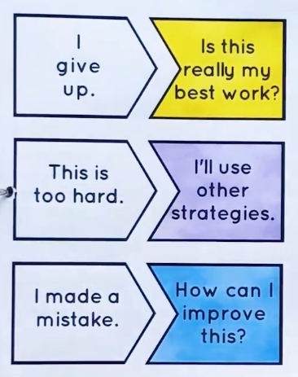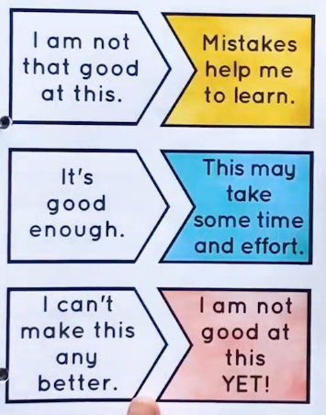
Answers:
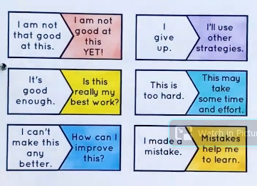

EXTRA TIME
For those keen for more!
Have a go at Northamptonshire Sports Weekly Personal Challenge!

Every week Northamptonshire sport will be releasing a challenge for every school to have a go at. The challenge will be released at 10am on a Monday on the link below:
We are on Week 4:
LOG YOUR SCORE HERE:
https://www.northamptonshiresport.org/virtual-school-games-challenges
Link to view challenge:
https://www.northamptonshiresport.org/virtual-school-games-challenges1

Go to:
Mr Pearce’s Physical activity Weekly Timetable- This gives you tasks to try every day!
“Getting more active” Document. This has lots of links to access
PA and PE Home Learning- Document in Get active section
For more PE lessons ideas:
- https://www.youtube.com/user/WestYorkshireSport

Afterschool Sports Club: Youth Sports Trust: Weekdays 5pm:
https://www.youtube.com/user/YouthSportTrust/videos

SEE YOU SOON!! Mr Pearce

