PE TOPICS:
Net/Wall Development and Hand Invasion Development
School Games value focus: Self Belief Gospel value Focus: Courage
Health and Wellbeing Focus: Growth Mindset

Please try and complete all tasks set below in this week’s PE plan.
Physical Activity starter:
Homecourt Maths Challenge!
Test your reactions of mind and body! Using the Homecourt App we have used before.
App can be found by typing in “HOME COURT”. The challenge is under “AGILITY” and the challenge tittle is “SPLIT STEP MATHS”. Have a go and see if you can beat your personal best!
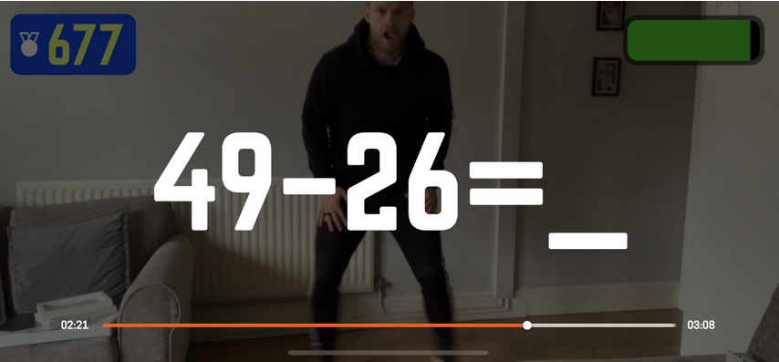
See Mr Pearce having a go here:
https://www.youtube.com/channel/UCqoFCJR6hInZrArFwgTFYuw
If no-one in your family has an iphone then write a number of maths sums on paper in large writing. Start doing some jumping jacks, then get your partner/parent/sibling to hold up a maths sheet that you have to answer whilst working doing the jumping jacks- count how many you can do in a minute.
PE lesson Part 1: Hand Invasion Development: Explore, Practice and Develop in this PE at Home Lesson below:
HANDBALL
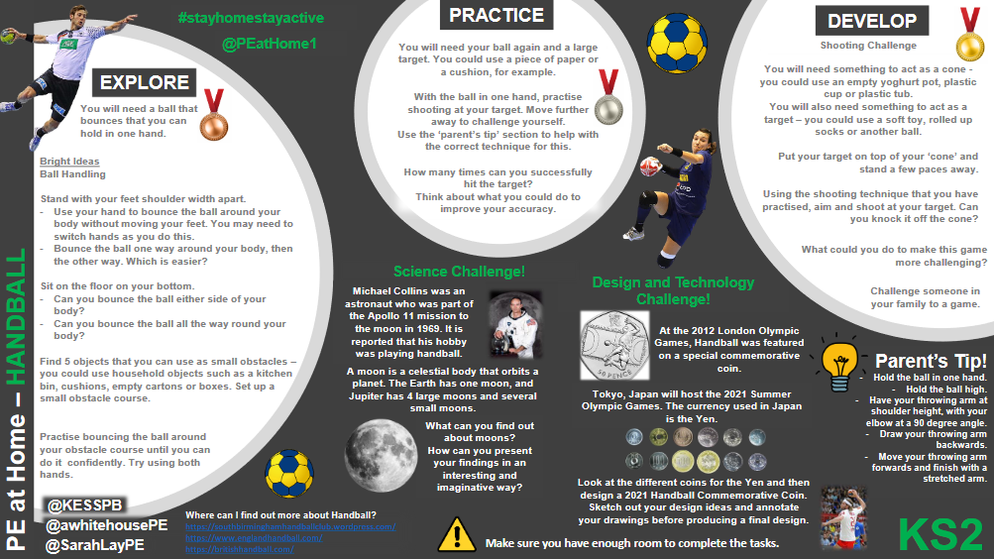

Cross Curricular: Net/Wall Worksheet
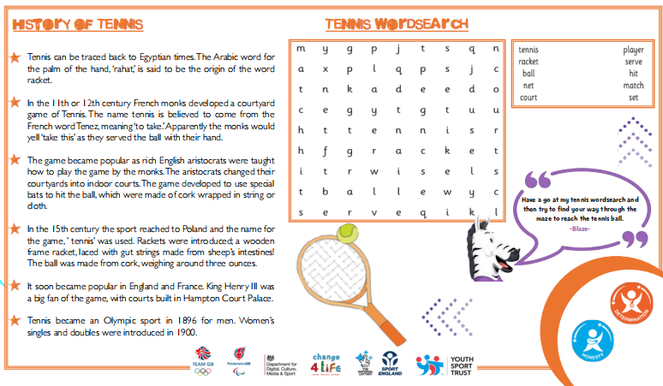

PE Lesson Part 2: Net/Wall Development:
Click the link, watch Mr Pearce’s Videos and have a go yourself!
Balloon Play!
Video 1: Chasse and Lunge!
Link: https://www.youtube.com/channel/UCqoFCJR6hInZrArFwgTFYuw
Video 2: Balloon Blast
Link: https://www.youtube.com/channel/UCqoFCJR6hInZrArFwgTFYuw


Have a go at Northamptonshire Sports Weekly Personal Challenge!

Every week Northamptonshire sport release a challenge for every school to have a go at. The challenge will be released at 10am on a Monday on the link below:
We are on Week 6
LOG YOUR SCORE HERE:
https://www.northamptonshiresport.org/virtual-school-games-challenges
Link to view challenge:
https://www.northamptonshiresport.org/virtual-school-games-challenges1

Research/Written Task:
Courage:


When would you need to show Courage in PE?
Write down three things.
- 1______________________________________________________________
- 2______________________________________________________________
- 3______________________________________________________________
Now write down three times you have shown Courage? What was the outcome?
- 1______________________________________________________________
- 2______________________________________________________________
- 3______________________________________________________________

EXTRA TIME
For those keen for more!
Have a go at Northamptonshire Sports Weekly Personal Challenge!

Every week Northamptonshire sport will be releasing a challenge for every school to have a go at. The challenge will be released at 10am on a Monday on the link below:
We are on Week 6:
LOG YOUR SCORE HERE:
https://www.northamptonshiresport.org/virtual-school-games-challenges
Link to view challenge:
https://www.northamptonshiresport.org/virtual-school-games-challenges1

Go to:
Mr Pearce’s Physical activity Weekly Timetable- This gives you tasks to try every day!
“Getting more active” Document. This has lots of links to access
PA and PE Home Learning- Document in Get active section
For more PE lessons ideas:
- https://www.youtube.com/user/WestYorkshireSport

Afterschool Sports Club: Youth Sports Trust: Weekdays 5pm:
https://www.youtube.com/user/YouthSportTrust/videos

SEE YOU SOON!! Mr Pearce

