Fantastic Four Fireball throwers!
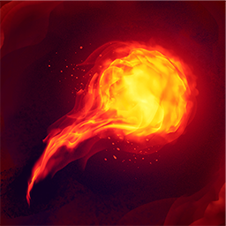
Game: FANTASTIC FOUR FIREBALL THROWERS (NOT ACTUALLY USING FIRE)
Best to play in the garden, but can play all around the house.
Requires two teams. E.g child and parent.
Each team member has a few rolled up socks, aim is to hit opponent with a sock with a fireball throw. Moving around set area/house
If hit lose that body part. If hit on a body part must lose that part. E.g hop if lose leg. Throw with other arm if hit on arm
Progressions/changes in game:
Change throwing arm
Can only throw under arm
Can us other soft items to throw. E.g sponge ball/ teddy bears
Equipment:
Area markers- make sure playing area has nothing that could trip anybody up- a safe area
Plenty of socks rolled up.

Flash’s Speed Challenge

Progressions/changes in game:
Hop over
Spin when jumping
Frog Jumps
Increase time
Increase distance have to jump
Equipment:
Something to jump over side to side, to create a small line
E,g: a sock laid flat. A T-shirt rolled
Game: FLASHES CHALLENGE
Flashes challenge is to do as many jumps side to side over marked line as many times as you can in 30 seconds.
How did it make your body feel?
Which parts of your body were you using?

Superman’s obstacle course
Progressions/changes in the game:
How could you make it more challenging?
Could you add a time limit?
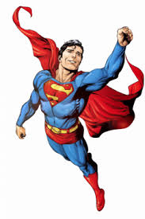
Game: SUPERMANS OBSTACLE COURSE
Can you set up an obstacle course around the house or in your garden that include:
Balance- being in control and steady with different body parts.
Agility – moving your body quickly and easily
Coordination- using different body parts to complete a task/activity.

Equipment:
Anything you want to use!

Spiderman’s web throwers
Game: SPIDERMANS WEB THROWERS
Have some targets set up with different distances away.
See how many you can knock over in a certain time.
E.g 30 seconds, then see if you can improve. Think what you could do to improve you accuracy of throw.

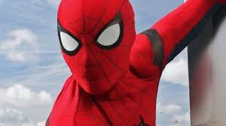
Progressions/changes in the game:
How could you make it more challenging?
Could you add a time limit?
Add different targets/small large
Change what you are throwing
Equipment:
Anything you can throw at a target e.g rolled up socks
Something to use as a target
e.g Teddy bears

