The Good Shepherd
Catholic Primary School



Following Jesus, The Good Shepherd, in all we say and do

Reception
Autumn 1 Curriculum Newsletter
2026-2027

In this booklet, we have included some information we feel you may find useful about the work your child will be doing this term. As well as the modules we will be covering in class, we have also included the objectives and expectations for each subject. We hope you will find this information useful and supportive and look forward to working with you across the year.

Mrs Hawkins, Mrs Maddison, Mrs Ashby and Miss Pearmain

Heavenly Father,
As we begin this new school year,
bless our children, families and school community.
May we follow the example of Jesus,
growing in faith, hope and love,
and treating one another with kindness and compassion.
May Mary, our Mother, pray for us
and guide us closer to her Son.
Lord, bless our journey together
and keep us always in Your loving care.
Amen.

Theme: Marvellous Me
What are we Reading and Writing about together this term?
I’m (almost) Always Kind  by Anna Milbourne | 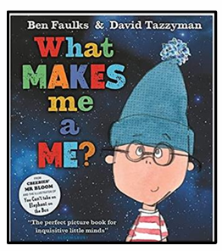
What makes me a ME?  by Ben Faulks & David Tazzyman | 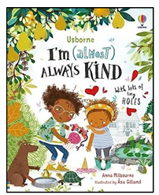
The Squirrels Who Squabbled  by Rachel Bright | 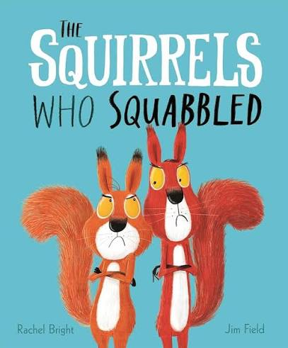
The Wonder  by Faye Hanson | 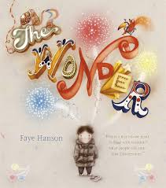
Pumpkin Soup  by Helen Cooper | 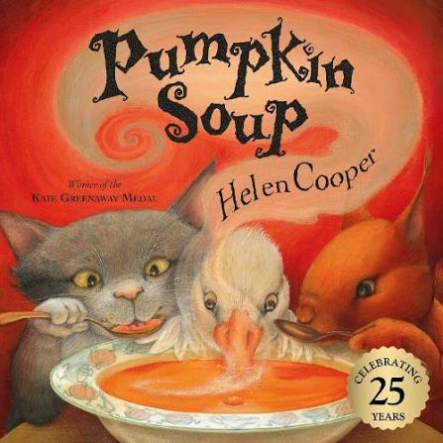

Parent Advisory
All books have a link to a YouTube video of the book being read aloud.
Please be aware that adverts may play before the video starts.

SUBJECT | TOPIC INFORMATION
RELIGIOUS EDUCATION | Saint Anthony | We will also be looking at our class saint, St Anthony.  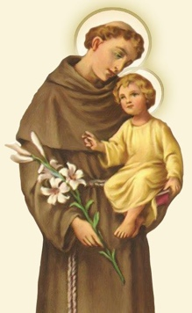
RELIGIOUS EDUCATION | Branch 1: Creation and Covenant
RELIGIOUS EDUCATION | Hear | God made our beautiful world and everything in it.  God made me.  Words and actions of the Sign of the cross.
RELIGIOUS EDUCATION | Believe | God made me.  God loves me. God loves everyone.  God made the wonderful world.  God is love.
RELIGIOUS EDUCATION | Celebrate | Give thanks for God’s Wonderful World.
RELIGIOUS EDUCATION | Live | Look after me.  Look after God’s world.
PHONICS | Phonics – Read, Write, Inc | - Start to learn to read and write set 1 sounds  - To read individual letters by saying the sound for them  - Read some letter groups that each represent one sound and say sounds for them (Fred Talk)
Neli Speech and Language |  | - Baseline  - Group interventions at specific levels.
MATHS | Block 1 - Counting | Counting, 0 – 3.
MATHS | Block 2 - Counting | Counting, 4 – 5.
MATHS | Block 3 – Pattern | To be able to recognise a pattern.
MATHS | Block 4 – Composition | To be able to count in sequence to 3.
MATHS | Block 5 – Composition | To be able to count in sequence to 5.
MATHS | Block 6 – Length and weight | Order and compare weights.  Compare weights of objects.

Children’s progress is evaluated on their learning outcomes in relation to 7 Early Learning Goals. The reformed Early Learning Goals are now statutory for all early years settings. Please see the 7 prime Early Learning Goals below:
Communication and Language | Learn to listen carefully and understand why listening matters. Develop questions, social phrases and new vocabulary linked to routines, relationships and the theme. Build confidence in whole-class, small-group and one-to-one talk.
Personal, Social and Emotional Development | Develop belonging, friendship, independence, emotional vocabulary, resilience and confidence. Learn classroom rules and routines and begin to manage own needs.
Physical Development | Develop safe movement, posture, balance, coordination and confidence. Strengthen fine-motor control and use tools with increasing independence.
Literacy | Build a love of books; develop comprehension through high-quality texts; segment and blend to read words; develop purposeful mark making and letter formation.
Mathematics | Build secure counting and subitising alongside mathematical language, positional language and practical problem solving.
Understanding the World | Explore family, community, immediate surroundings, senses and seasonal change. Begin to compare experiences and notice changes over time.
Expressive Arts and Design | Explore colour, materials, tools, music and imaginative play while developing confidence to make choices and express ideas.

