Some things to do together
  4 new sounds I’ve heard today | Try to keep a note / a picture of 4 new each day, building discrimination and listening skills. Perhaps start a large sheet of paper and add to each day – reviewing what has already been heard. It will get more difficult as time goes by, but will really encourage listening skills.
  4 new things I’ve spotted today | As above, but encouraging careful looking.
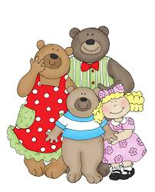  Change the ending | Share a story (new or well loved) and decide to change the ending – what will happen? Who will be involved? How will you remember the new ending?
  Targets | Set up outside or on a hard floor inside. Use bowls of water, chalked circles on the path, trays … Targets could be a colour (throw the pebble into the blue pot), a numeral (aim for number 5), a letter sound (aim for the ‘sss’) ..
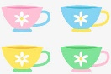  Role play | Gather a few items together to support some make-believe play: cup, spoon, jug, plate, pen, paper (Café); cake cases, mixing bowl, wooden spoon, cake tin (cooking); brush, comb, empty shampoo bottle (hairdresser) … Play together with the adult modelling language eg ‘what would you like?’, ‘mix, whisk…’, ‘trim, conditioner, parting…’
  Garden / indoor assault course | Include crawling, jumping, balancing etc. Consider using number cards eg a ‘5’ on the mat, a ‘4’ on the chair so that the planned action is repeated that number of times eg 5 star jumps when you get to the mat, 4 chair press-ups …
  Water painting outside | A bucket of water and different sized brushes. Adult and child paint together. Adding glitter could be fun!
Learn a new song/rhyme with actions   | Learn a rhyme or song, make some actions to accompany it and share with friends via video / Facetime …
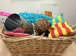  Heuristic play | Gather junk materials, lids, cds, boxes, curtain rings etc for children to explore, sort, build… Support the child by sitting nearby and encouraging, but without becoming physically involved with the resources unless intervening for safety reasons.
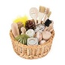  Treasure Basket | Gather sets of everyday items for very young children to explore safely: wooden objects, shiny objects, fabrics …
  Treasure Hunt | Select two or three items and show to child. Explain that you are going to hide them and give them ‘hot and cold’ clues (as appropriate). Provide a magnifying glass (homemade??), a torch to help focus the child on the task. Swap – can they hide objects for you?
Feely Bag guessing game |   Use a bag / empty cushion cover etc and add just 2-3 items. Encourage child to close eyes and feel, talking about what they can feel – cold, squidgy … and then let them guess what the object might be.
  Find and sort | Make collections of things when out in the garden – leaves, flower petals, blossom. Sort by shape, colour … add to containers to sort or glue onto paper.
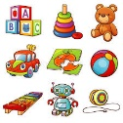  Collage | Cut out a number of pictures from magazines/ catalogues of a mixture of things – recipes, toys, books, cars … let child select picture. Discuss – do they like / not like? Do they have that toy? Would they like that toy? Have they tried that fruit … make a picture “things I like / don’t like” by sticking onto paper
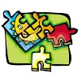  Puzzle making | Cut out large pictures / print photos and cut into a number of pieces (depending on age / ability of child) and create a puzzle, gluing back together.
Just a few ideas of activities to enjoy together. Pick those your child might be interested in.

Most importantly – have fun!

