  Gospel: The 27th Sunday of Ordinary Time Year A (Matt 21:33-43)  Jesus said to the chief priests and the elders of the people, ‘Listen to this parable. There was a man, a landowner, who planted a vineyard; he fenced it round, dug a winepress in it and built a tower; then he leased it to tenants and went abroad. When vintage time drew near he sent his servants to the tenants to collect his produce. But the tenants seized his servants, thrashed one, killed another and stoned a third. Next, he sent some more servants, this time a larger number, and they dealt with them in the same way. Finally, he sent his son to them. “They will respect my son” he said. But when the tenants saw the son, they said to each other, “This is the heir. Come on, let us kill him and take over his inheritance.” So, they seized him and threw him out of the vineyard and killed him. Now when the owner of the vineyard comes, what will he do to those tenants?’ They answered, ‘He will bring those wretches to a wretched end and lease the vineyard to other tenants who will deliver the produce to him when the season arrives.’ Jesus said to them, ‘Scripture tells us,  It was the stone rejected by the builders  that became the keystone.  This was the Lord’s doing  and it is wonderful to see.‘I tell you, then, that the kingdom of God will be taken from you and given to a people who will produce its fruit.’ |   Reflection:  In today's Gospel we hear a parable about how some people responded to God's messengers. Jesus is talking to a group of religious leaders in Jerusalem. The point that Jesus is making to them through the parable is direct and critical.  He wanted people to understand more about God and the job that Jesus had come to do on earth. The owner of the vineyard represents God, the servants represent the prophets – who were God’s messengers to the people – and owner’s son is Jesus.  This Gospel gives us a clear message about the importance of listening to God's word. God speaks to us in many ways—through Scripture, through Church tradition, in the Church's teaching, and through modern-day prophets. (Often people in our everyday lives!) We must ask ourselves…are we attentive and receptive to God's Word to us through these messengers? God sends people to help us love and obey Him. How do we respond to them? If we are like the wicked tenants in the parable, then we need to change our ways if we want to be the best possible version of ourselves and to belong to the Kingdom of God.
 |   Challenge:  - Can you remember a time when you felt rejected by someone?  - Now that you have reflected on what it felt like to experience rejection, think what it means to know that God loves you no matter how many times you reject Him.  - What does it say about God that, even though his love has been rejected so many times, he continues to reach out to us?  - This parable was told as a warning to the Jewish leaders, but what lessons can we learn from it for our lives today? | October is the month of the Holy Rosary.  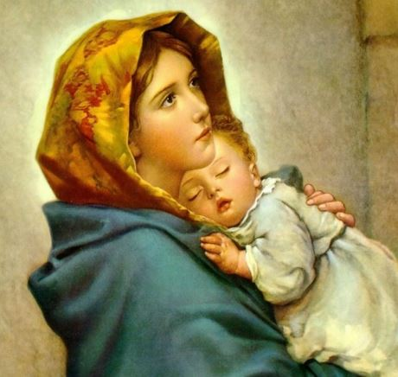  We ask Mary, Mother of Jesus to pray with us as we ask for the wisdom to be more open to God's messengers in our lives:  Hail Mary, full of grace,  The Lord is with thee.  Blessed art thou amongst women and blessed is the fruit of thy womb, Jesus.  Holy Mary, Mother of God,  Pray for us sinners now,  And at the hour of our death, Amen

