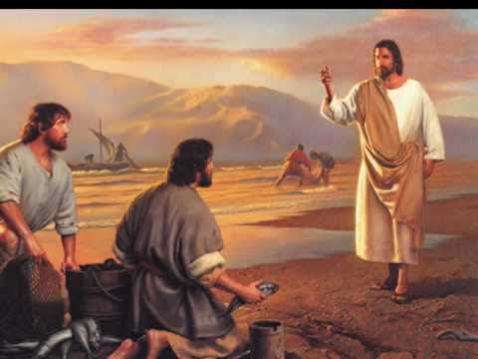  Gospel Reflection  In this Gospel, we learn about two different aspects of Jesus’ ministry. Firstly, He preaches about repentance and the Good News about the Kingdom, following on from John the Baptist. Secondly, he calls the first four of his disciples in order to teach them how to ‘catch people’ rather than fish. When Jesus called his first disciples, the Gospel tells us that the fishermen (Peter and Andrew, James and John) dropped everything to follow Jesus immediately. They clearly saw something very special in this man called Jesus. It is not always easy to walk away from the things we want to do in order to do what Jesus wants us to do. We often feel that we are being pulled in many different directions with our families, our friends and our studies. We can find it hard to prioritize! In this Sunday’s Gospel, Jesus calls us all to repent and follow him, making Him our life’s priority. Like the first disciples we need to be single minded as we follow Jesus by making the right choices in our lives. | Gospel  3rd Sunday of Ordinary Time Year A  After John had been arrested, Jesus went into Galilee. There he proclaimed the Good News from God. ‘The time has come’ he said ‘and the kingdom of God is close at hand. Repent, and believe the Good News.’  As he was walking along by the Sea of Galilee he saw Simon and his brother Andrew casting a net in the lake – for they were fishermen. And Jesus said to them, ‘Follow me and I will make you into fishers of men.’ And at once they left their nets and followed him.  Going on a little further, he saw James son of Zebedee and his brother John; they too were in their boat, mending their nets. He called them at once and, leaving their father Zebedee in the boat with the men he employed, they went after him.  Mark 1:14-20 |   “Jesus was sent to bring the Good News, to enter the hearts of each one of us.” Pope Francis  Can you be the ‘Good News’ to those around you?  How would you feel if Jesus appeared in your school today and asked you to follow Him?  Would it change you in any way?
Today let’s pray together that we will respond as quickly as the first disciples when Jesus calls us to follow him and to catch the hearts of all people.

Dear God, You call each and every one of us to follow you and to proclaim your Good News to people who are poor, hungry, sad, lonely, bullied, scared, or weary. May we always respond positively and do all that we can to answer that call. We ask this through Christ our Lord. Amen.

Post-it Challenge:

Jesus’ first disciples responded with absolute certainty when Jesus interrupted their daily routine and called them to a new life and to follow him.

- How does God call us today?
- How do we know that God is calling us?
- How do we respond to the call?
- What work does Jesus ask us to do?
- Do we make this a priority?

