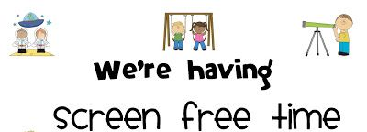
Build a mini-marshmallow catapult or tower. Instructions in Files.
Video Links:- https://youtu.be/c0I8W0aO4ew Year 6 Screen Free Day
https://youtu.be/zA6_PURTpUk Mrs Maule’s Banana Cake

Build a den with pillows and blankets and read a book.
Science. Carry out an experiment to see which biscuit is best for dunking. Instructions in Files.
Watch my video in Teams Files, A Friday with Mrs Maule, 12th Feb. Lots of ideas!
BAKE! Two really easy recipes are in Files to print off. Also, a video.
Build a light spectrum spinner. Instructions to print off in files.
Write a letter to a friend.
Build a Rube Goldberg Machine.
Go for a walk!
Grab a board game and challenge a sibling or adult.

Science Spinner Instructions


