Interim Headteacher: Jackie Robinson

Interim Assistant Headteachers: Maria Hawkes and Rebecca Shields
Kingsland Gardens
Kingsthorpe
Northampton
NN2 7BH

Telephone: (01604) 714399
Fax: (01604) 714672
E-mail:
head@thegoodshepherd.northants-ecl.gov.uk

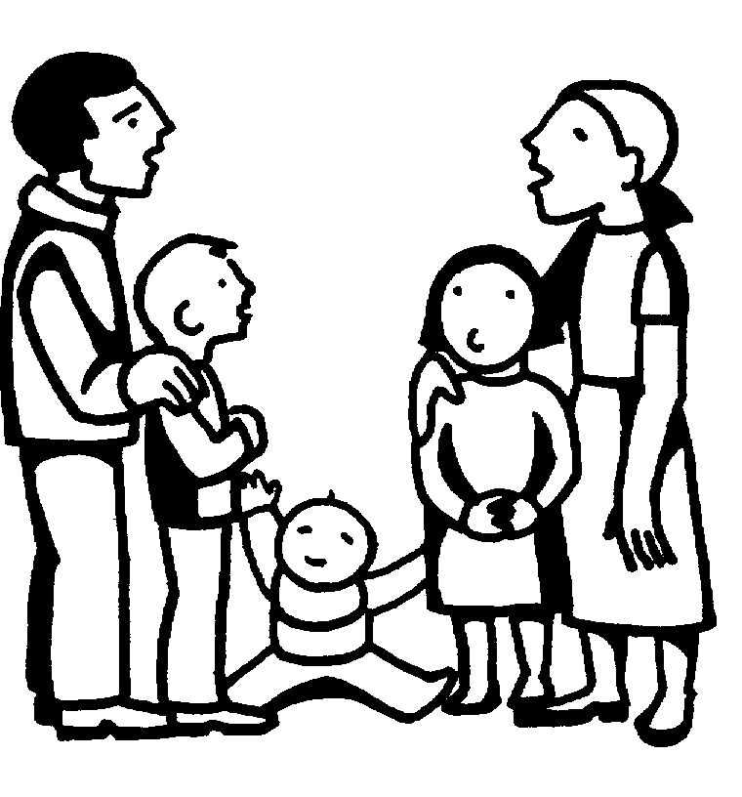
THE GOOD SHEPHERD CATHOLIC PRIMARY SCHOOL
The Catholic Diocese of Northampton
“Following Jesus, The Good Shepherd, in all we say and do”

Catholic Diocese of Northampton

Photography Consent Form

Occasionally, we take photographs of the children at our school. We may use these images in our school prospectus or in other printed publications that we produce, in displays and on our website and social media.

We also send images to the news media, or our school may be visited by the media who will take their own photographs or film footage (for example, of a visiting dignitary or other high profile event). Pupils will often appear in these images. The news media may use the images in printed publications (including local or national newspapers), on televised news programmes or on their website. They then store them in their archive. They may also syndicate the photos to other media for possible use, either in printed publications, on websites, or both. When we submit photographs and information to the media, we have no control on when, where, if or how they will be used.

To comply with GDPR, we need your permission before we can photograph or make any recordings of your child.

Conditions of use:

- This form is valid for the period of time your child attends this school. Images of your child will not be used after this time. Please write to the school if you wish to withdraw consent at any time.
- The images we take will be of activities that show the school and children in a positive light.
- Embarrassing or distressing images will not be used. The images will not be associated with negative or sensitive issues.
- We may use group or class photographs or footage with very general labels e.g. ‘science lesson’.
- We will only use images of pupils who are suitably dressed.
- We will make every effort to ensure that we do not allow images to be taken of any children for whom we do not have permission or who are ‘at risk’ or disallowed from having their photographs taken for legal or social reasons.
- We will take all reasonable measures to ensure the images are used solely for the purposes for which they are intended. However we cannot guarantee this and take no responsibility for the way images are used by other websites or publishers or for any consequences arising from publication.

Please note that websites can be viewed throughout the world and not just in the United Kingdom where UK law applies. In giving your consent you understand that images may be used in printed and electronic form.

To give your consent, please complete the information overleaf and return the form to the school.

Please tick those that apply:

I give permission for my child’s image to be taken and used at school and in publicity material

for the school, including printed and electronic publications, video and webcam recordings and on websites/social media.

I give permission for images of my child to be used by the news media in printed and/or electronic form and stored in their archives. This might include images sent to the news media by the school and images / footage the media may take themselves if invited to the school to cover an event.

I do not want my child’s image used in any publicity

I have read and understood the information overleaf.

Name of child: __________________________________________________________

Parent’s or carer’s signature: __________________________________________________________

Name (in block capitals): __________________________________________________________

Date: __________________________________________________________

If you require help completing this form or a translated version, please contact the school office.

