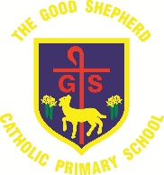
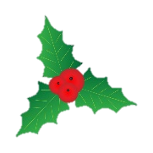
Class Christmas Party Information

Next week children will enjoy their class Christmas parties! Children are invited to wear party clothes or Christmas jumpers on the day.
Due to Covid-19 restrictions, children will not be able to share party food. Therefore, children can bring in an individual bag of party food – e.g. crisps, a cake/chocolate bar, a drink. Please no fizzy drinks or products containing nuts.
Thank you!

Class/Bubble | Class Party Date
RN and R1A | Friday 18th November 2020
1L | Wednesday 16th December 2020
2P and 2C | Wednesday 16th December 202
3C, 34D and 4P | Friday 18th November 2020
5A and 5C | Friday 18th November 2020
6P and 6M | Friday 18th November 2020
Rainbow Room | Thursday 17th November 2020

