PE TOPICS:
Outdoor Adventurous Activity and Multi Skill Development
School Games value focus: Teamwork Gospel value Focus: Forgiveness

Physical Activity starter:
Get outside as soon as you have an opportunity!! Walk, Run, Jog, Cycle, GeoCache, Scoot, PLAY!:

PE lesson Part 1: Outdoor Adventurous Activity: Explore, Practice and Develop in this PE at Home Lesson below:
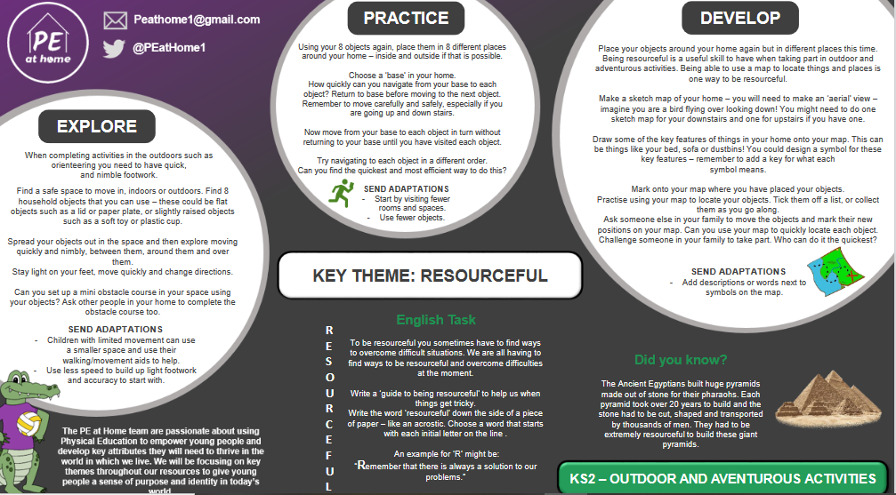

PE Lesson Part 2: Multi Skill Development:
Have a go at Northamptonshire Sports Weekly Personal Challenge!

Every week Northamptonshire sport will be releasing a challenge for every school to have a go at. The challenge will be released at 10am on a Monday on the link below:
We are on Week 3- Boccia
LOG YOUR SCORE HERE:
https://www.northamptonshiresport.org/virtual-school-games-challenges
Link to view challenge:
https://www.northamptonshiresport.org/virtual-school-games-challenges1
Try the HOME COURT CHALLENGE!
See Mr Pearce’s attempt here, then have a go! https://www.youtube.com/watch?v=tt57TThev1c 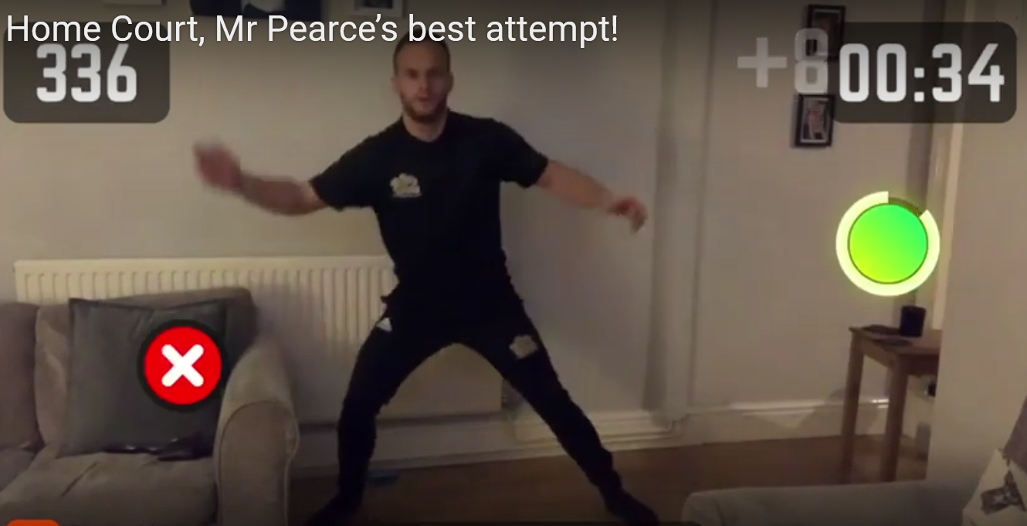
To have a go you need to download the app “HomeCourt”, click “Agility” and then Click “Reaction”
How did you feel after the workout?
What did you do to improve?
Can you try one of the other challenges?

If you want, go and try another workout on the Homecourt app. There are soo many to choose from!

Research/Written Task:
Complete a SMART goal
Set yourself a goal to complete using the SMART goals tool:
SPECIFIC (clear end point)
MEASURABLE (able to track your progress)
ATTAINABLE (needs to be something that is possible)
RELEVANT (should be for you, benefit you directly)
TIME BOUND (need a time frame to complete)
e.g Running 5km in under 25 minutes. This is Specific and Measurable and is also Attainable. It is Relevant because you are actively trying to get into shape. I would just need to say when I want to do it by. So by the end of March. I now have a SMART goal!
My Goal is:

Cross Curricular Activities:
- Play the game you created in week 4 (See PE lesson Week 4 if unsure)
- How could you make it a TEAM game?

RECAP: Have you completed all the activities set by Mr Pearce over the last 6 weeks?
See below cross off what you have completed, if you have something left to do… just go and do it!
Outdoor Adventurous Activity: | Multi Skill Challenges | Cross Curricular
I have been Geocaching  (Week 1 and 2) | I have Completed a Northamptonshire sport challenge and logged my score  (Week 3,4,5,6) | I have created a new game  (Week 4)
I have gone on a Scavenger hunt  (Week 4) | I have done the Speed Stack challenge (Week 3) | I know what a SMART goal is  (Week 3 and 6)
I have marked what I need to do to complete the National Trust Tasks  (Week 5) | I have done the Home Court Challenge (Week 5 and 6) | I understand the words TEAMWORK and FORGIVENESS  (Week 1,2,3,4,5,6)
I have done the PE at Home OAA Lessons (Week 3 and 6) | I have tried a superhero FUN activity.  (Week 1 and 2) | I have tried some MATHS ON THE MOVE (Week 3)

EXTRA TIME
For those keen for more!
Have a go at Northamptonshire Sports Weekly Personal Challenge!

Every week Northamptonshire sport will be releasing a challenge for every school to have a go at. The challenge will be released at 10am on a Monday on the link below:
We are on Week 3- Boccia
LOG YOUR SCORE HERE:
https://www.northamptonshiresport.org/virtual-school-games-challenges
Link to view challenge:
https://www.northamptonshiresport.org/virtual-school-games-challenges1

Go to:
Mr Pearce’s Physical activity Weekly Timetable- This gives you tasks to try every day!
“Getting more active” Document. This has lots of links to access
PA and PE Home Learning- Document in Get active section
For more PE lessons ideas:
- https://www.youtube.com/user/WestYorkshireSport

Afterschool Sports Club: Youth Sports Trust: Weekdays 5pm:
https://www.youtube.com/user/YouthSportTrust/videos

SEE YOU SOON!! Mr Pearce

