Let’s DREAM (DRop Everything And Move) at the Good Shepherd!

Strong evidence proves that regular physical activity is associated with numerous health and education benefits for
children.
The UK Chief Medical Officers recommend that all children and young people should engage in physical activity of moderate to vigorous intensity for at least 60 minutes every day.

What can we do to support this? Our school already offers an average of two hours of PE or other physical activities per week. However, we need to do more to encourage children to be active every day.

It is suggested that at least 30 minutes of physical activity should be delivered in school every day through active breaktimes, extra-curricular clubs, active lessons or other sport and physical activity events. The remaining 30 minutes supported by parents and carers outside of school time.
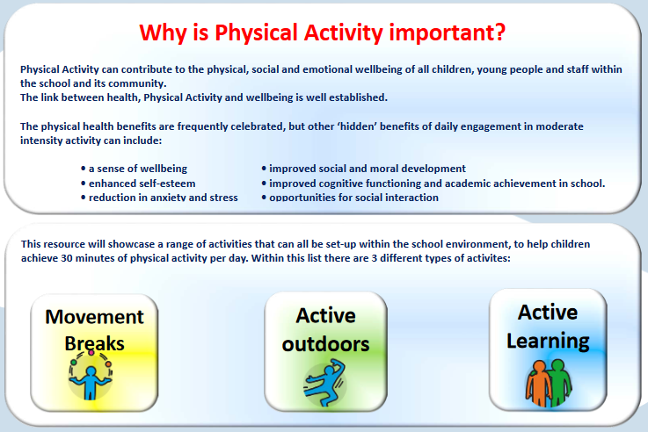

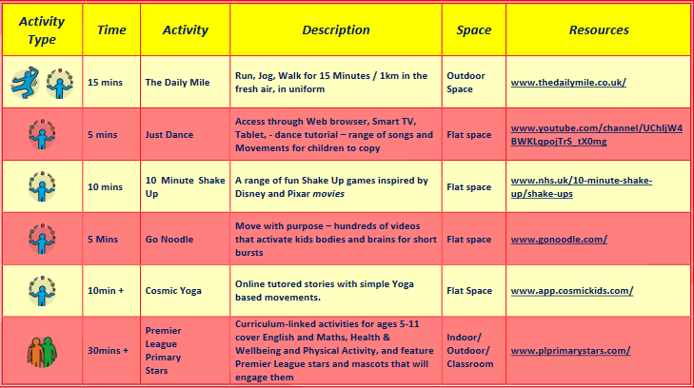
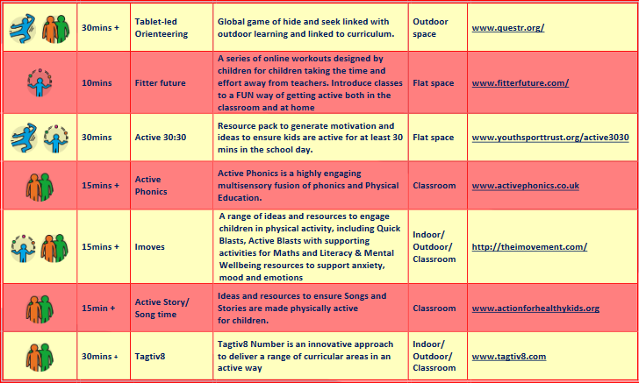
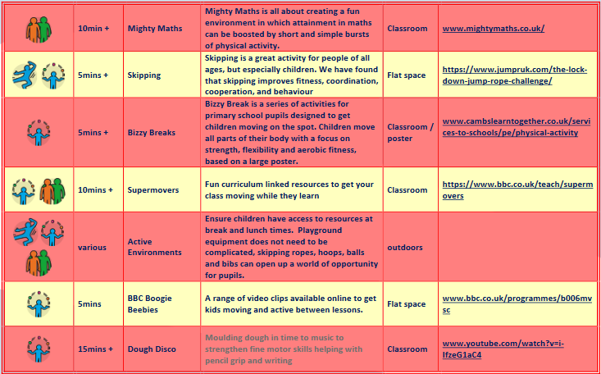
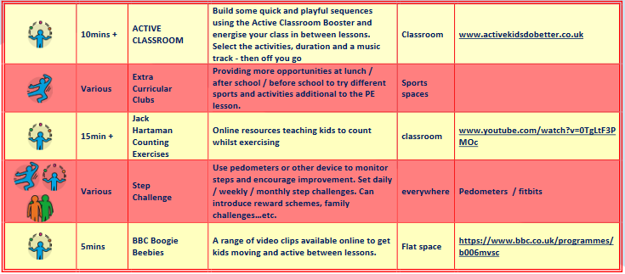

Links for the above activities!
Daily mile: http://www.thedailymile.co.uk/  Just Dance: http://www.youtube.com/channel/UChIjW4BWKLqpojTrS_tX0mg  10 minute Shake up:  http://www.nhs.uk/10-minute-shake-up/shake-ups  Go Noodle: http://www.gonoodle.com/  Cosmic Kids: http://www.app.cosmickids.com/  Premier League Stars: http://www.plprimarystars.com/  Orienteering: http://www.questr.org/  Fitter Future: http://www.fitterfuture.com/  Active 30/30: http://www.youthsporttrust.org/active3030  Active Phonics: http://www.activephonics.co.uk/  Imoves: http://theimovement.com/ | Active Story: http://www.actionforhealthykids.org/  Taktiv8: http://www.tagtiv8.com/  Mighty maths: http://www.mightymaths.co.uk/  Skipping: https://www.jumpruk.com/the-lock-down-jump-rope-challenge/  Bizzy Breaks: http://www.cambslearntogether.co.uk/services-to-schools/pe/physical-activity#  BBC Super Movers: https://www.bbc.co.uk/teach/supermovers  BBC Boogie Beebies: http://www.bbc.co.uk/programmes/b006mvsc  Dough Disco: http://www.youtube.com/watch?v=i-IfzeG1aC4  Active Classroom: http://www.activekidsdobetter.co.uk/  Jack Hartaman Counting exercises: http://www.youtube.com/watch?v=0TgLtF3PMOc

