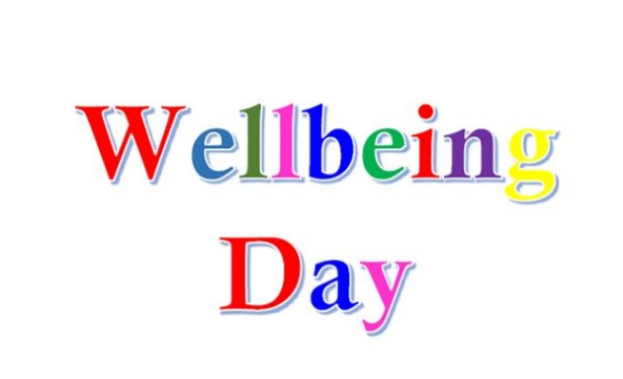
Year 1 Wellbeing Day – Friday 12th February 2021

9:00 – 9:30 Music on Teams
9:30 – 10:00 Catch up with Mrs Bowen on Teams
10:00 – What activity are you going to be doing today? Are you doing a project as a family? Are you making something? Are you learning a new skill?
Please find some ideas in the files - (nb some were planned for a week)
Remember not to be using a screen!
Looking forward to seeing your photos.
Have fun,
Mrs Bowen and Mrs Coe.

