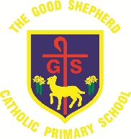
Class Christmas Production Video Release Dates

Due to Covid-19 restrictions, this year each bubble will be releasing a Christmas video for parents and family members to enjoy at home.
The video will be released on the below date by 17.00 on Microsoft Teams. Please sign in with your child’s login information and go to ‘files’. RN and R1A can find there video on…
Merry Christmas!
Class/Bubble | Release date
RN and R1A | Thursday 17th December 2020
1L | Wednesday 16th December 2020
2P and 2C | Wednesday 16th December 2020
3C, 34D and 4P | Thursday 10th December 2020
5A and 5C | Thursday 17th December 2020
6P | Thursday 17th December 2020
6M | Friday 18th December 2020
Rainbow Room | Tuesday 15th December 2020

